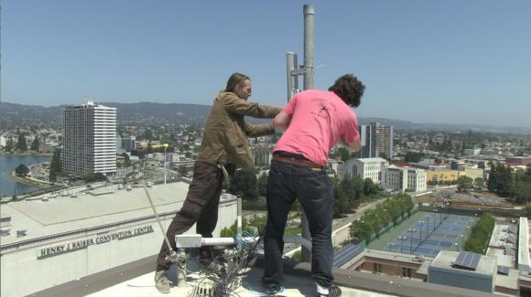

People’s Open Network
Node Owners Manual
January 2018

Welcome to the People’s Open Network
Thank you for hosting a node on the People’s Open Network!
We're a small Oakland-based all-volunteer non-profit working to create a local community owned and operated network based on point-to-point wifi links between apartments and houses. Our long-term goal is to cover the bay area in free wifi, get free internet to neighborhoods that are under-connected, and create an open alternative to corporate ISPs for last-mile connectivity.
Since 2013 we've been developing open source wifi router software based on OpenWRT that makes it easy for anyone to participate in the mesh. As of the winter of 2018 we have over 60 notes operating and we’re adding more every week!
We also host free hands-on workshops where we educate anyone interested in wireless and network technology on the basic skills and knowledge needed to build their own internet(s). Visit peoplesopen.net/workshop for details on the next upcoming workshop. You can also join us on the on the last Tuesday of every month at Sudo Room, located inside the Omni Commons at 4799 Shattuck Ave, Oakland, California 94609.
By hosting a node you are helping to:
- Take back control of the internet with a community-owned and operated network
- Build a network that can withstand natural disasters and resist censorship
- Provide internet to underserved parts of our community
You can follow our progress at:
- peoplesopen.net/blog
- github.com/sudomesh
- #peoplesopen on Patchwork
- twitter.com/pplsopennet
- facebook.com/peoplesopen

Your Node

Ethernet Ports
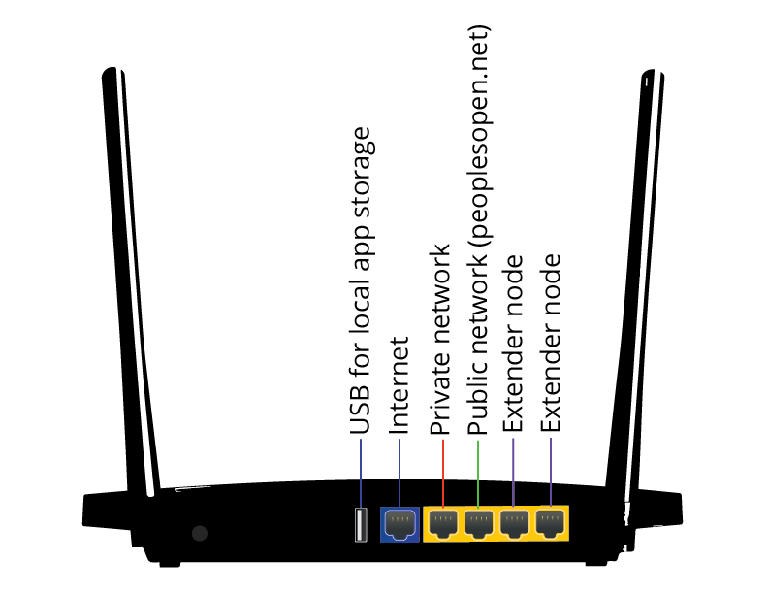
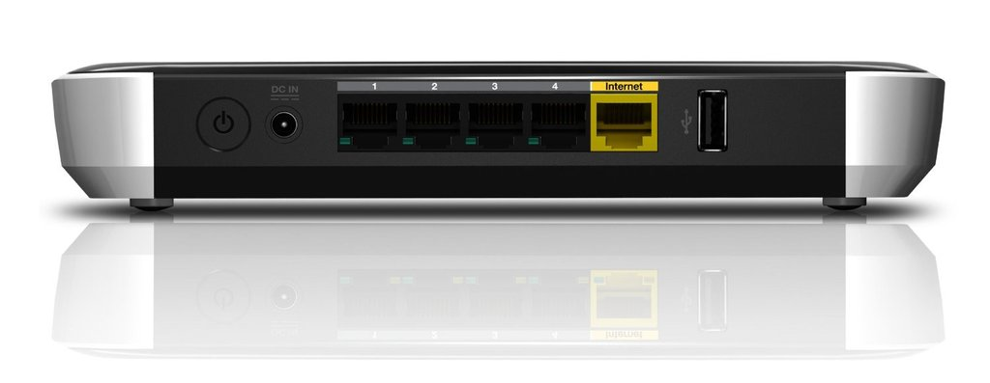
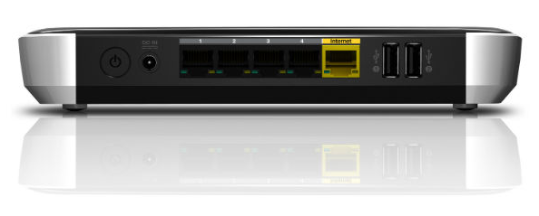
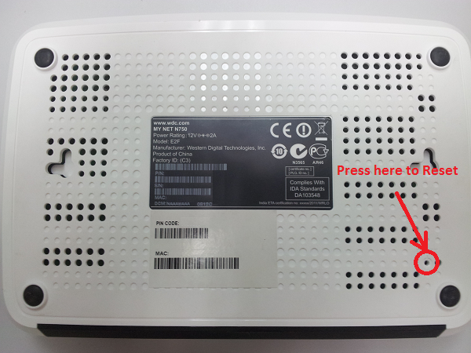

Mounting Your Node
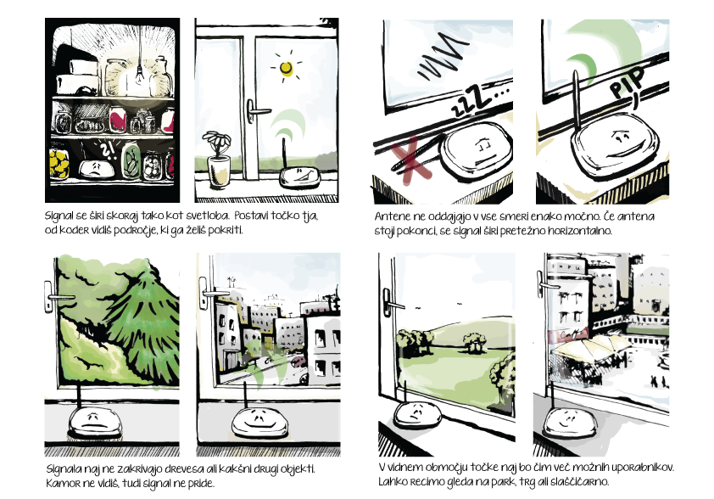  The wireless signal spreads like light. Put the node in an area where you can see what you wish to cover. | Antennas do not broadcast in all directions equally. If the antenna is up the signal spreads mostly horizontally.
The signal cannot pass through trees or other objects. The signal only goes where you can see. | Place the node where it can see as many users as possible. No we can see the other buildings and the market.

Extender Nodes
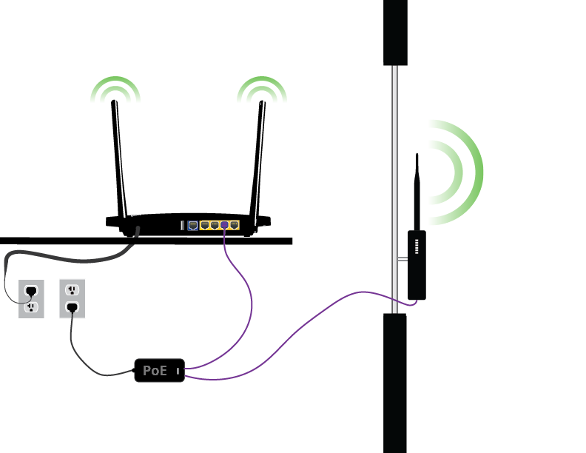

Configuring Your Node
Web Admin Interface:
http://privatenode.sudomesh.org/
You have to be connected to the private SSID
The admin username is: admin

The Network
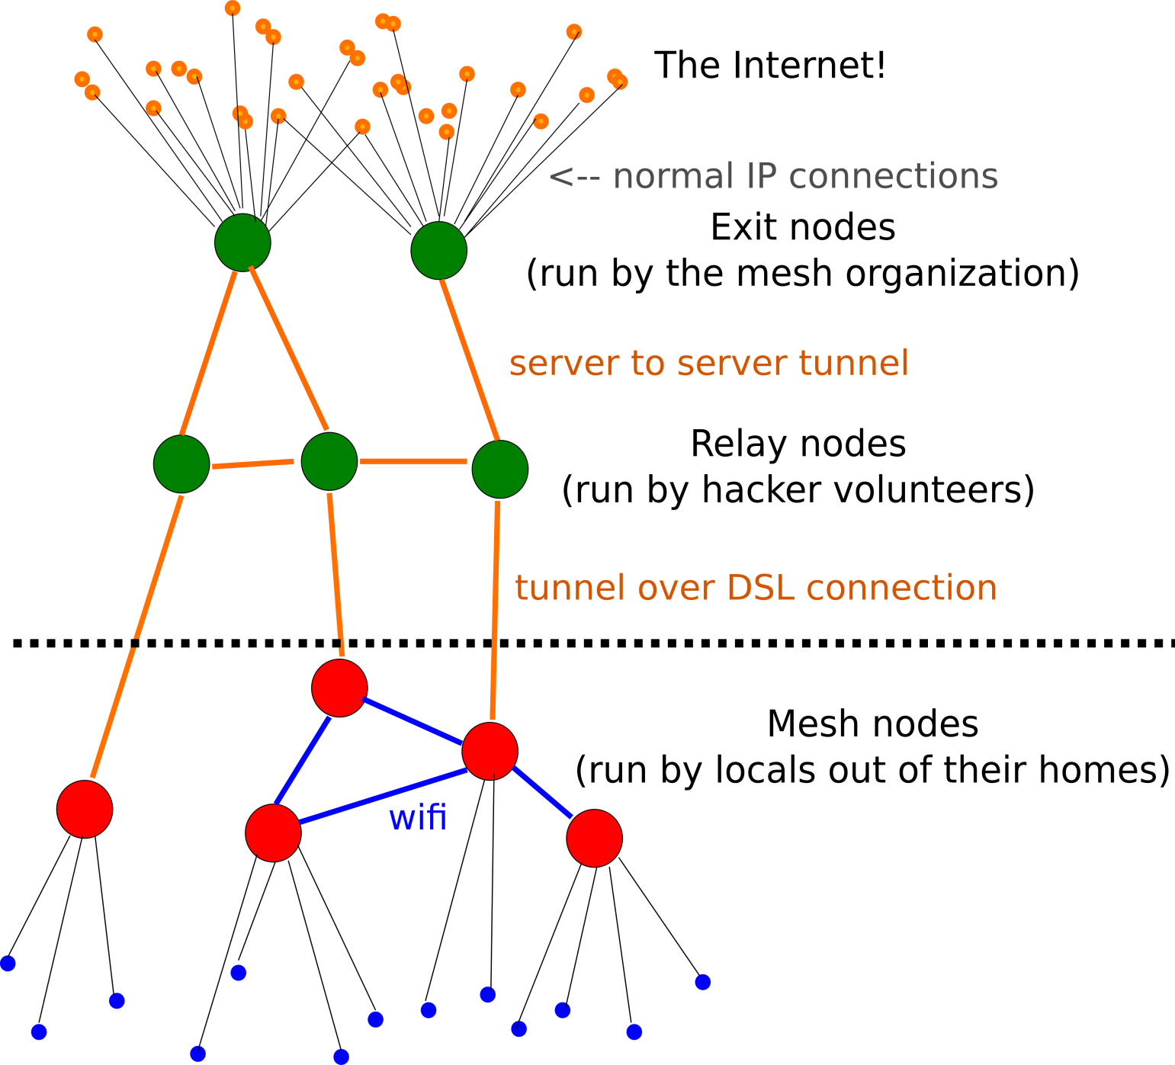
The red dot is your node! The blue dots are people’s devices (laptops, tablets, phones, etc.). If you share part of your home internet bandwidth, the traffic from these devices will be routed through your node and then tunneled through the network connectivity of your internet service provider to our exit nodes where it finally reaches the internet. If your node is not connected directly to the internet but it is within reach of another node, the traffic from the devices will hop through your node to the other node and then tunnel through that node’s ISP to our exit nodes.

